Name: _____________________ Class:__________ Date:__________
Instructions: Write answers in the right-hand column. Score: ___________ / 53 marks
Section A— Multiple choice (10 marks)

 | Chemists use symbols to identify each element. Recall which feature is true of these symbols.  A they mostly contain one or two letters  B they always use the first letter of the element name  C they are arranged in the periodic table alphabetically  D they must use only capital letters | A | 1
 | Identify the correct statement about the properties of compounds.  A The properties of compounds are impossible to describe.  B The properties of compounds are different to those of the elements they are made from.  C The properties of compounds are the average properties of the elements that make them up.  D The properties of compounds are the same as the elements they are made from. | B | 1
 | Identify what the chemical structure shown here represents  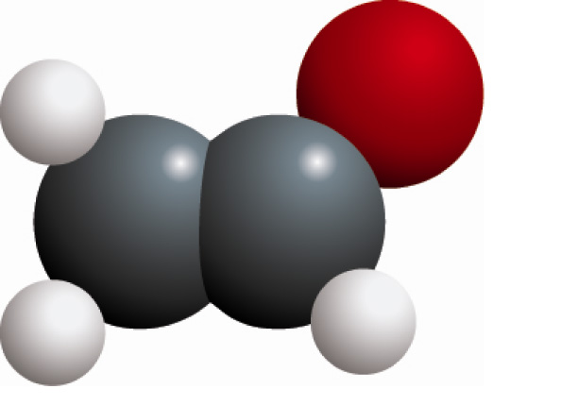  A a molecular element  B a lattice element  C a molecular compound  D a lattice compound | C | 1
 | Recall which element has the chemical symbol K.  A copper  B cobalt  C polonium  D potassium | D | 1
 | An atom consists of:  A a nucleus containing neutrons and protons, surrounded by a cloud of electrons.  B central neutrons, surrounded by a cloud of electrons and protons.  C central electrons, surrounded by a cloud of protons.  D a mixture of protons and electrons spread evenly in a neutral ‘dough’. | A | 1
 | Tap water is best described as:  A an element  B a compound  C a mixture  D an alloy | C | 1
 | Determine which of the following statements about molecular compounds is not true.  A the molecules are identical  B the molecules contain the same types of atoms but may have different numbers of each type.  C the molecules contain more than one type of atom  D the molecules can be broken down into their elements | B | 1
 | Identify which list contains only properties of metals.  A brittle, conduct heat, conduct electricity  B malleable, electrical insulator, ductile  C dull appearance, crumble, gas at room temperature  D ductile, malleable, conduct electricity | D | 1
 | A nitrogen atom has 7 protons, 7 neutrons and 7 electrons. Determine what the correct atomic symbol would be.  A 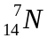  B 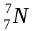  C 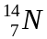  D 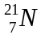 | C | 1
 | Recall how the electron cloud and nucleus are held together.  A they have opposite electronic charge that attracts them together  B they have a similar electronic charge that attracts them together  C they are chemically bonded to each other  D the gravitational pull of the heavy nucleus attracts the light electrons | A | 1
Section B— Short answer (22 marks)
- ` | Define each of the following.  a element  b atom  c molecule  d compound | a a pure substance (made of one type of atom)  b the smallest part of an element  c a group of atoms bonded together  d a pure substance made of more than one type of atom. | 4
 | a Sketch a molecule of NH₃.  b Determine the chemical formula for the molecule shown below.  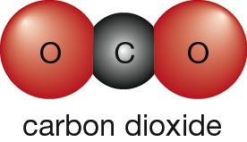 | a 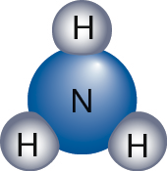  b CO₂ | 2
 | Identify and name the elements whose symbols are given below.  a Al  b Ca  c Au  d He  e O  f Mg  g Kr  h Pb  i S  j Zn | a aluminium  b calcium  c gold  d helium  e oxygen  f magnesium  g krypton  h lead  i sulfur  j zinc | 5
 | Identify the symbol for each of the following.  a hydrogen  b chlorine  c silver  d neon  e lithium  f boron  g iodine  h iron  i tin  j carbon | a H  b Cl  c Ag  d Ne  e L  f B  g I  h Fe  i Sn  j C | 5
 | Define a mixture. | A substance made up of two or more pure substances (i.e. elements and compounds) | 1
 | List the only two elements that are liquid at room temperature (Hint: one is a metal and the other is a non-metal) | mercury (Hg), bromine (Br) | 2
 | List three properties of:  a metals  b non-metals | Answers may include:  a metallic lustre, malleable, ductile, conduct electricity, conduct heat  b dull appearance, brittle, electrical insulators, thermal insulators | 6
 | Contrast iron and steel. | Iron is an element that is soft and rusts easily. Steel is an alloy made up of iron mixed with other elements to make it strong and more rust resistant. | 2
 | Calculate the number of protons, neutrons and electrons in a calcium atom with the atomic symbol 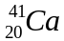 | 20 protons, 21 neutrons and 20 electrons | 3
 | Propanol has the molecular formula C₃H₇OH. Determine they type of atoms in each molecule and the number of each type of atom. | 3 carbon  8 hydrogen  1 oxygen | 3

Section C— Thinking scientifically (10 marks)

 | The chart below divides elements into 5 groups where the letters V, W, X, Y and Z represent an example of each.  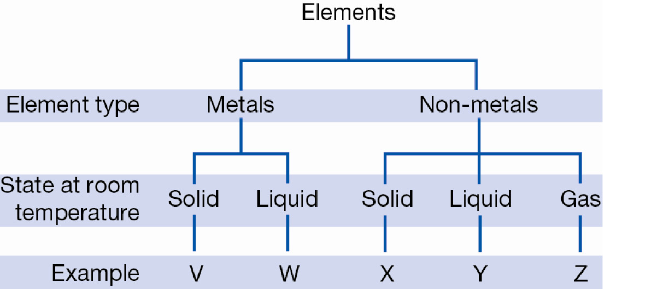  Given that bromine is the only non-metal liquid at room temperature, it can be inferred that bromine could be:  A Y only  B W or Y  C W only  D X, Y or Z | A | 1
 | The conductivity of a metal is a measure of how well the metal transmits an electrical current. Usually, the conductivity will change with temperature as shown for four metals in the graph below.  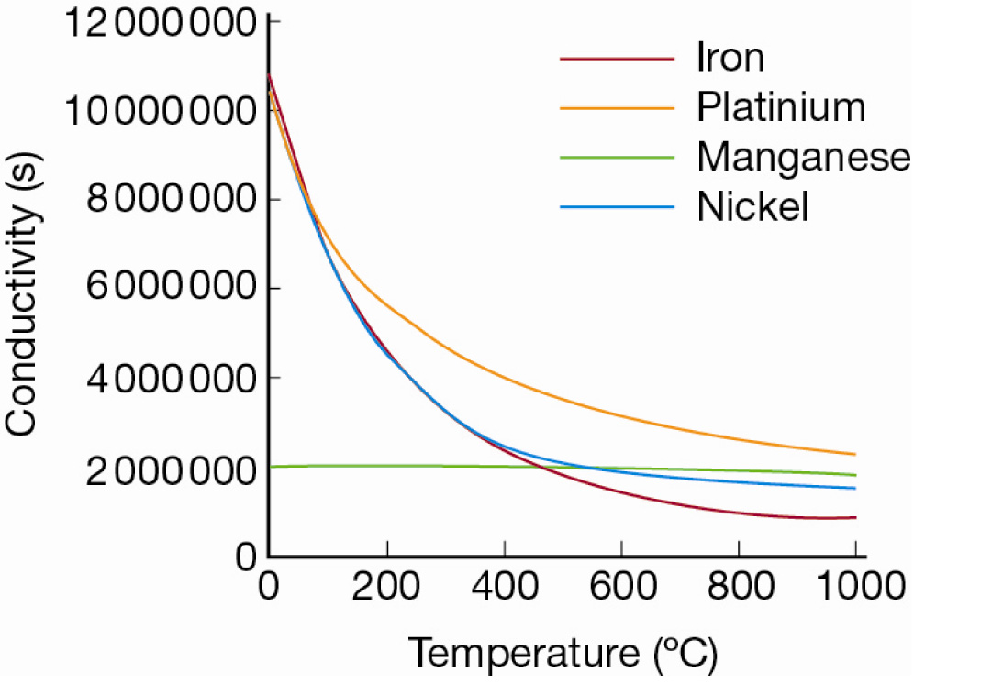  According to this graph, the best conductor at 700°C is:  A iron  B platinum  C manganese  D nickel | B | 1
 | The atomic symbol for an atom is made up of the chemical symbol, the atomic number (number of protons in the nucleus) and the mass number (number of protons plus neutrons in the nucleus). Below is an example of the atomic symbol for a calcium atom, which as 20 protons and 20 neutrons.  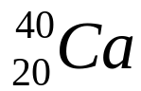  Given that an atom has 26 protons and 30 neutrons. Its atomic symbol would be:  A 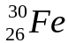  B 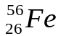  C 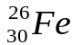  D 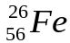 | B | 1
 | 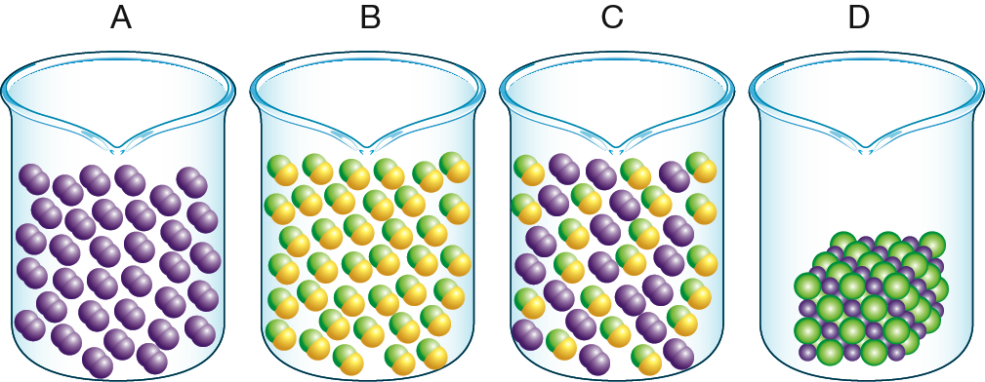  A molecular compound is a pure substance that is made up of identical particles where each particle contains atoms from two or more elements. Which of the following is the best representation of a molecular compound? | B | 1
 | When two substances are combined to form a mixture, the substance that makes up most of the mixture is called the dispersion medium. The substance that is mixed into the dispersion medium is called the dispersed phase.  Different types of mixtures are given different names depending on whether the dispersion medium and the dispersed phase are solids, liquids or gases. The table below shows some of the names given to different types of mixtures.  From this table, the scientific term for a fog on a cold winter’s morning would be:  A emulsion  B gel  C aerosol  D sol | C | 1
   |  | Dispersion medium
  Dispersed Phase |  | Solid | Liquid | Gas
  Dispersed Phase | Solid | solid solution  alloy (for metals)  solid sol | solution  sol  suspension | solid areosol
  Dispersed Phase | Liquid | solution  gel | liquid solution  emulsion | aerosol
  Dispersed Phase | Gas | solid foam | solution  foam | gas solution
 | The following statements about elements are all true:  - Elements are substances made up of just one type of atom.  - The atoms in elements can form molecules or crystal lattices.  - Elements can be metallic or non-metallic.  - Solid, non-metallic elements can be made up of molecules or crystal lattices.  - All solid, metallic elements are made up of crystal lattices.  From this information you can deduce:  A A crystal lattice is always metallic.  B A solid, non-metal element is always made up of molecules.  C A solid element made up of molecules cannot be metallic.  D A solid, non-metal is never made up of a crystal lattice. | C | 1
 | An engineer is researching different types of cables to be used on a new type of aeroplane. The cables must be very strong to withstand the force of the wind as the plane travels very fast through the atmosphere. However, the cables must also be very light so the plane can take off quickly.  The engineer has narrowed it down to the four options shown in the graph below.  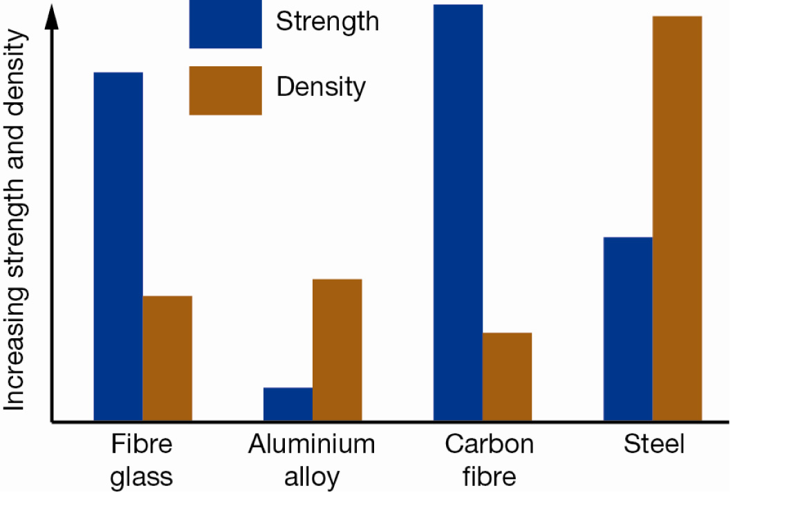  Which of these types of cables would be the engineer’s best option?  A fibre glass  B aluminium alloy  C carbon fibre  D steel | C | 1
 | Solder is an alloy (metal mixture) of tin and lead. It is used to connect electrical wiring together because it conducts electricity well and has a low melting point, but sets hard once it’s cooled.  The melting point of the solder alloy depends on the proportions of tin and lead in the solder.  Mark wants to use solder to connect some copper wires to a very sensitive electrical circuit. It is important that the electrical circuit does not get too hot so Mark must find the solder alloy with the lowest melting point. Use the graph below to determine what type of solder Mark should use to protect his electrical circuit.  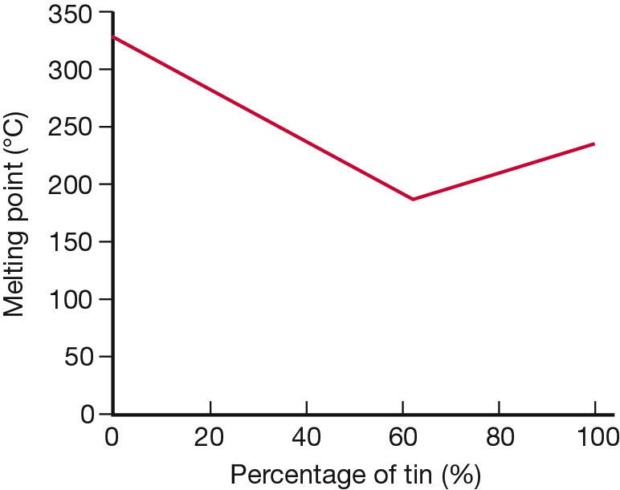  A 0% tin and 100% lead  B 50% tin and 50% lead  C 60% tin and 40% lead  D 100% tin and 0% lead | C | 1
 | Lithium atoms have an atomic number of 3. When they lose one electron, they become a charged particle known as a lithium ion with an electronic charge of +1. Identify which of the diagrams below would represent a lithium ion.  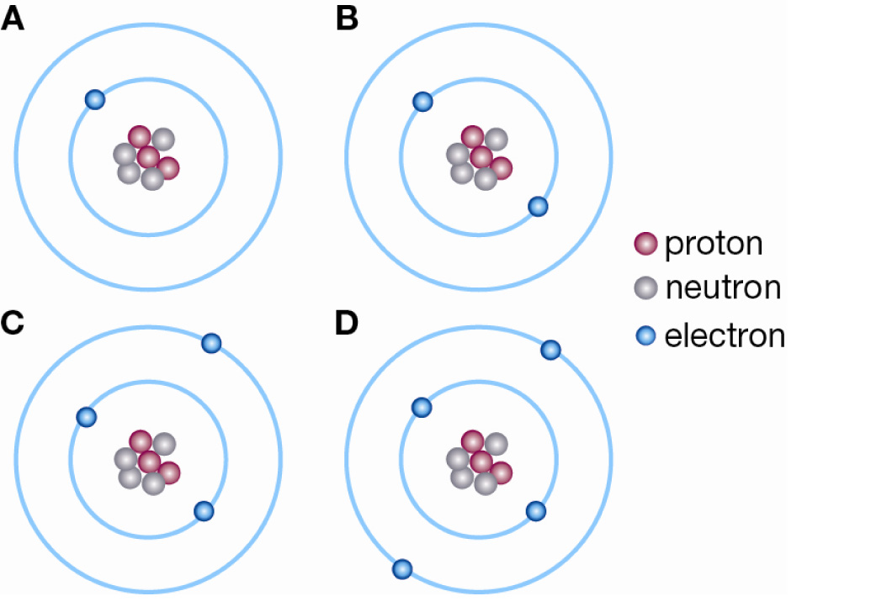 | B | 1
 | The molecular formula for a compound tells you what type of atoms are in the molecules and how many of each. For example, the molecular formula for water H₂O tells you that there are two hydrogen atoms (H) and one oxygen atom (O) in each molecule of water.  A common compound found in coffee, bread and ripe fruit is acetaldehyde, which has the molecular formula C₂H₄O. Which of the following diagrams would best represent a molecule of acetaldehyde?  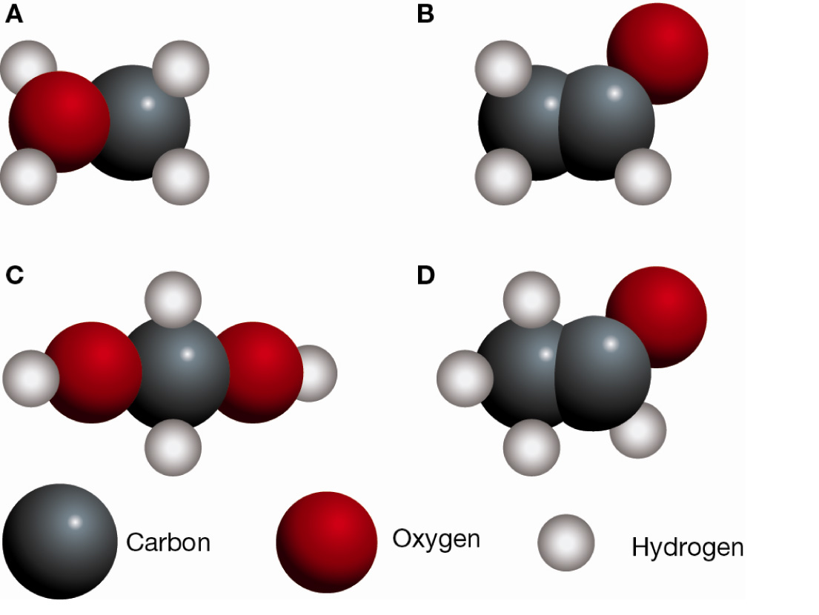 | D | 1

